CSE 310 Lab 1

Questions from the lab

1. TCP, DNS, ARP
2. 0.011272s
3. The internet address of gaia.cs.umass.edu is 128.11.245.12

The internet address of my computer is 10.245.247.201

1. Printouts on next page

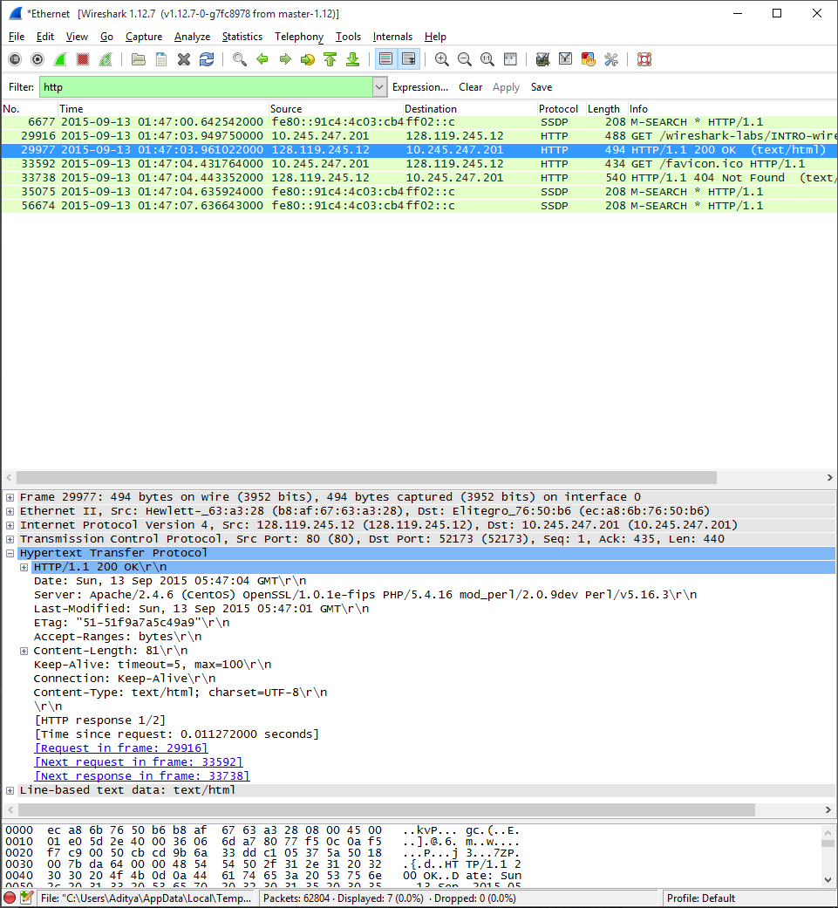

Questions on assignment

1. <Questions answered above, printouts attached>
   1. Internet Protocol Stack :
   2. 488 Bytes
   3. HTTP :
      1. Starts at Byte 55
      2. The last 4 bytes contain “....”

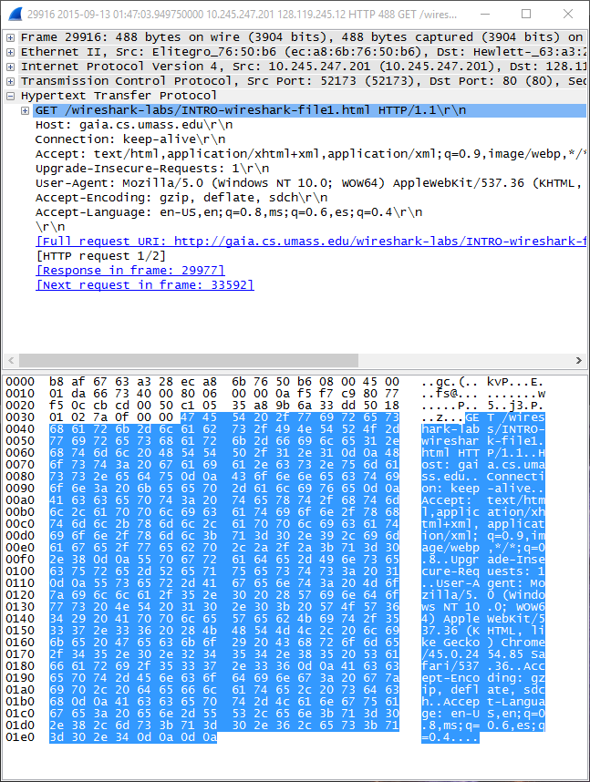

* 1. TCP :
     1. Size : 20 Bytes
     2. Starts at Byte 35

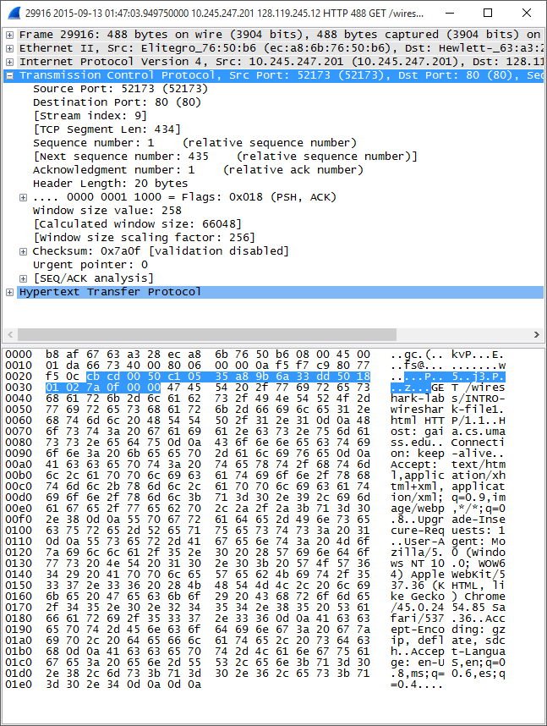

* + 1. IP
       1. Size : 20 Bytes
       2. Starts At Byte 15

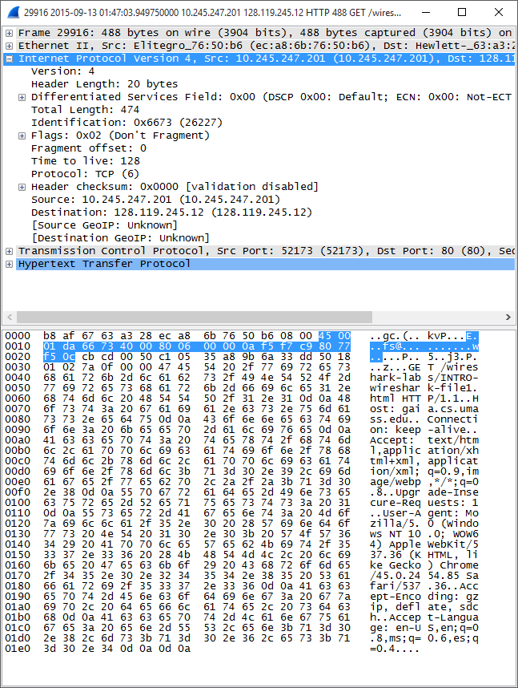

* + 1. Ethernet II
       1. Size : 14 Bytes
       2. Starts at Byte 1

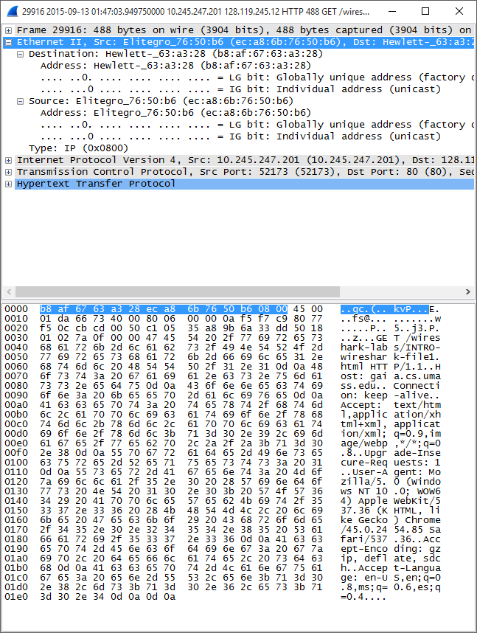

* 1. Yes, all these chunks combined form the enter frame
  2. Assuming all three links are of same length
 $$Total Time=T_{propagation}+T_{transmission} \\ Number of Packets=\frac{FileSize}{PacketSize}=\frac{80000bytes}{1000bytes}=80 \\ T_{propagation}=\frac{Distance}{PropagationRate}=\frac{1000000m}{2*{10}^{8}m/s}=0.005s$$

 $$T_{transmission}=\left(NumPackets+2\right)*\frac{PacketSize}{BitRate}=\left(82\right)*\frac{8000bits}{5000000bits/s}=0.1312s \\ Total Time=0.1362s$$

3. Now the links aren’t the same. Alice – R1 and R2 – Bob are same however R1 – R2 is faster. So the time can be calculated as

$$Total Time=T_{propagation}+2*T_{Alice-R1 \& R2-Bob}+T_{R1-R2} \\ Number of Packets=\frac{FileSize}{PacketSize}=\frac{80000bytes}{1000bytes}=80 \\ T_{propagation}=\frac{Distance}{PropagationRate}=\frac{1000000m}{2*{10}^{8}m/s}=0.005s$$

$$T_{Alice-R1\&R2-Bob}=\left(NumPacks+1\right)*\frac{PacketSize}{BitRate}=\left(81\right)*\frac{8000bits}{5000000bits/s}=0.1296s$$

$$T_{R1-R2}=\frac{PacketSize}{BitRate}=\frac{8000bits}{7000000bits/s}=0.0011s$$

$$Total Time=0.1356s$$